**DAILY ONLINE ACTIVITIES SUMMARY**

|  |  |  |  |  |  |  |  |  |
| --- | --- | --- | --- | --- | --- | --- | --- | --- |
| **Date:** | **25-06-2020** | | | | | **Name:** | **Anix Jugal D’Cunha** | |
| **Sem & Sec** | **8 sem , A sec** | | | | | **USN:** | **4AL16CS013** | |
| **Online Test Summary** | | | | | | | | |
| **Subject** | | **SMS** | | | | | | |
| **Max. Marks** | | **60** | | **Score** | | | **Marks Email was not Provided by TechGig** | |
| **Certification Course Summary** | | | | | | | | |
| **Course** | **Learn PHP - For Beginners** | | | | | | | |
| **Certificate Provider** | | | **Udemy** | | **Duration** | | | **2 hours** |
| **Coding Challenges** | | | | | | | | |
| **Problem Statement:** Program to calculate electricity bill | | | | | | | | |
| **Status: Competed** | | | | | | | | |
| **Uploaded the report in Github** | | | | | **yes** | | | |
| **If yes Repository name** | | | | | **alvas-education-foundation/dcunhaanixjugal** | | | |
| **Uploaded the report in slack** | | | | | **yes** | | | |

Online Test Details: (Attach the snapshot and briefly write the report for the same)

Email was not Provided by TechGig

Certification Course Details: (Attach the snapshot and briefly write the report for the same)

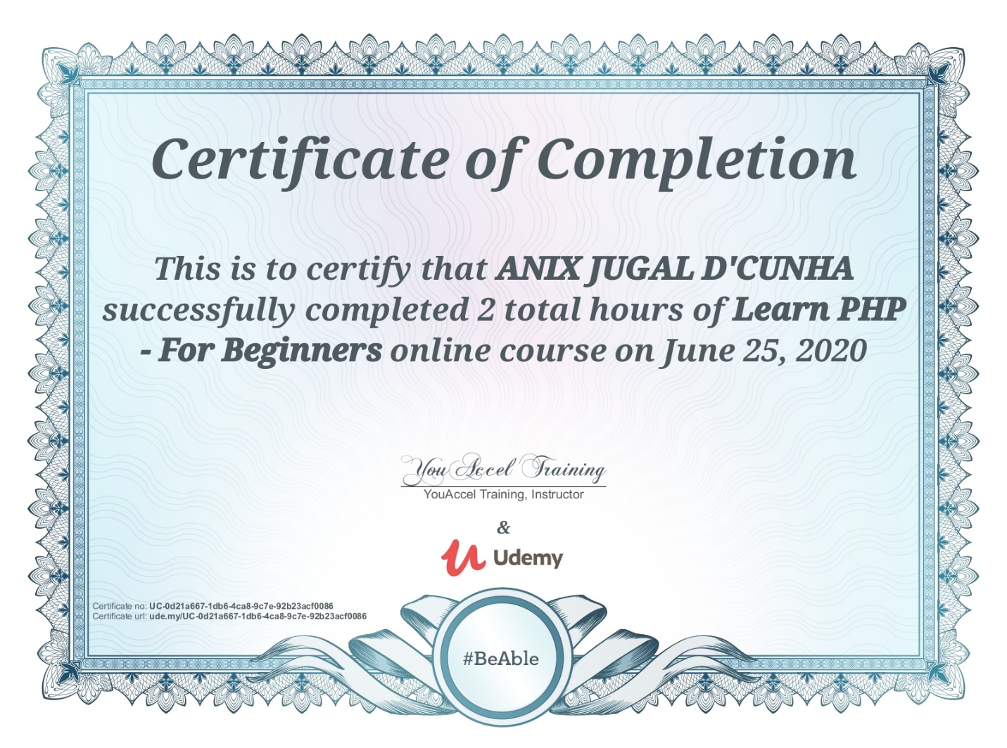

Coding Challenges Details: (Attach the snapshot and briefly write the report for the same)

## Program->  Program to calculate electricity bill

|  |
| --- |
| # include <stdio.h> |
|  | int main() |
|  | { |
|  | int unit; |
|  | float amt,total_amt,sur_charge; |
|  | printf(“enter total unit consumed:”); |
|  | scanf(“%d”,&unit); |
|  | if(unit<=50) |
|  | { |
|  | amt=unit*0.50; |
|  | } |
|  | else if(unit<=150) |
|  | { |
|  | amt=25+((unit-50)*0.75); |
|  | } |
|  | else if(unit<=250) |
|  | { |
|  | amt=100+((unit-150)*1.20); |
|  | } |
|  | else |
|  | { |
|  | amt=220+((unit-250)*1.50); |
|  | } |
|  | sur_charge=amt*0.20; |
|  | total_amt=amt+sur_charge; |
|  | printf(“electricity bill = Rs. %.2f”,total_amt); |
|  | return 0;  } |
|  | OUTPUT: |
|  | enter total unit consumed: 150 |
|  | electricity bill = Rs.120.00 |
|  |  |
|  |  |
|  |  |
|  |  |
|  |  |
|  |  |
|  |  |
|  |  |